**Assignment**

Write out 5 not-so-common terminal commands, explain what each does in about 50 words each. And specifically provide visual evidence of testing 2 out of these commands.

**Linux Commands**

1. Cal
2. Man
3. Useradd
4. Usermod
5. Passwd
6. **Cal:** The cal command in Linux displays a calendar in the terminal. By default, it shows the current month, but you can view any month or year by specifying them (e.g., cal 7 2025). It's useful for checking dates quickly without opening a separate calendar application.

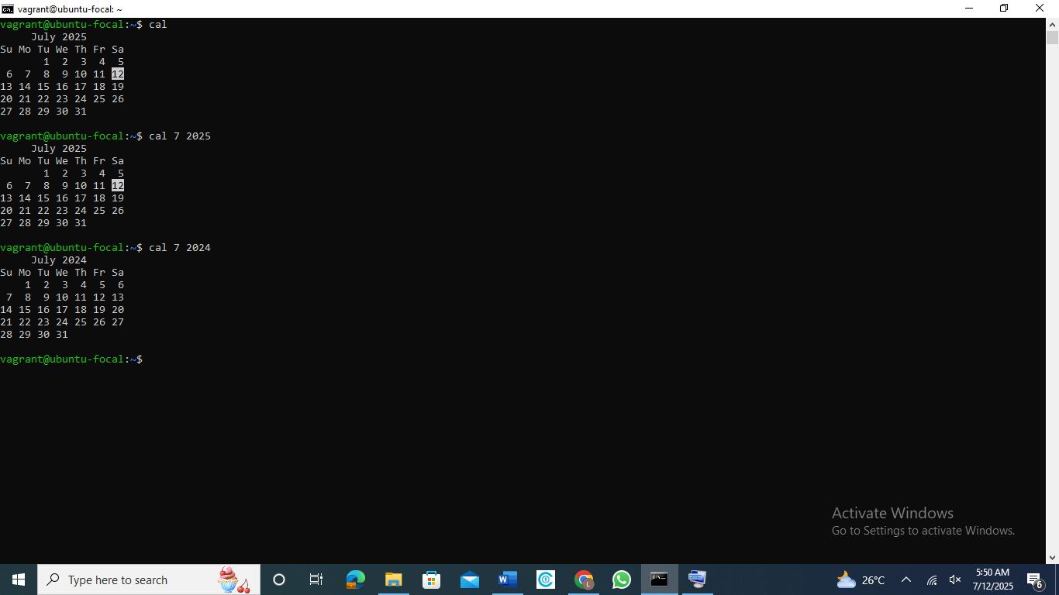

1. **Man:** The man command in Linux displays the manual pages for other commands, providing detailed information on their usage, options, and syntax. It's a helpful tool for understanding how a command works. For example, man dd shows the manual for the dd command. You can use q to quit the manual viewer.

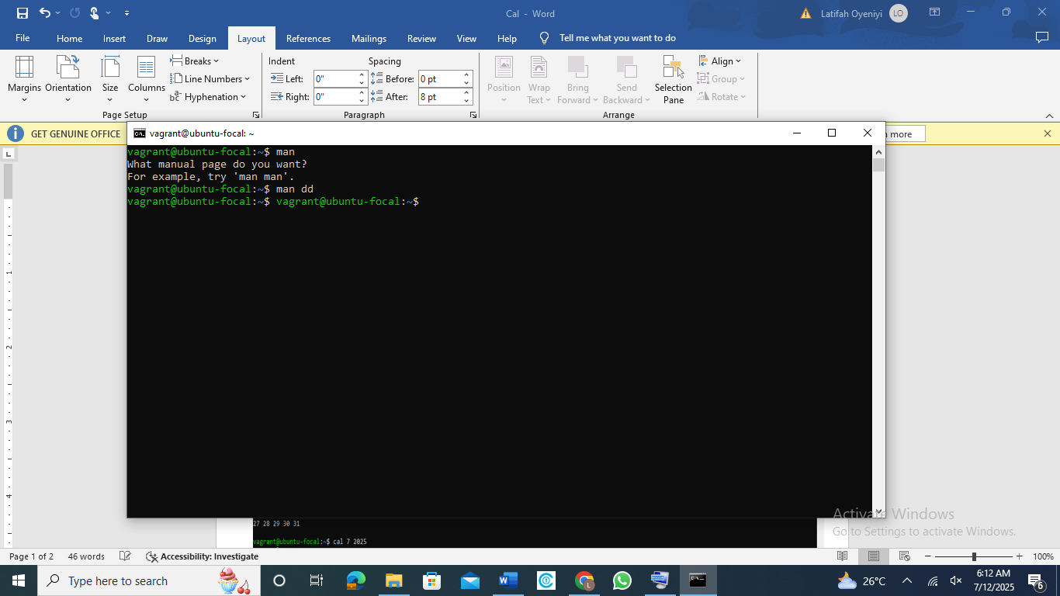

***This is visual evidence of output of man dd:***

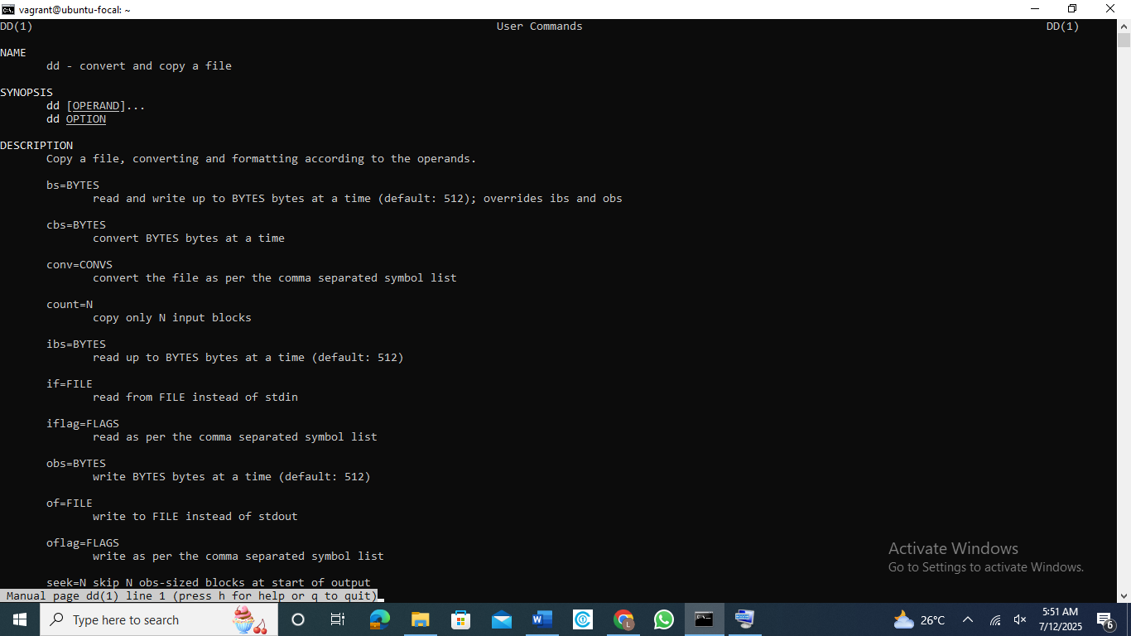

1. **Useradd:** The useradd command in Linux is used to create a new user account. It adds a user to the system with default settings, including creating a home directory if specified. For example, you can create a new user wale. You can also customize options like shell, user ID, and group with flags. Example: useradd -m -s /bin/bash username.
2. **Usermod:** The usermod command in Linux modifies an existing user account. It allows changes like updating the username, home directory, login shell, or group memberships. For example, usermod -l teephah wale renames a user. It's useful for managing user settings without deleting and recreating the account.
3. **Passwd**: The passwd command in Linux is used to change a user's password. When run without arguments, it updates the current user's password. Administrators can change other users' passwords using passwd username. It's essential for account security and enforcing password policies. Users are prompted to enter the new password twice. And the beautiful thing I realized is the security, while you type the password, it is blank, so no one gets to see what you are typing.